Chapter 5 Lab (Upload to Chapter 5 Lab dropbox)
Create a Word document and answer these questions:

Q1. Go to www.passwordmeter.com and create 5 passwords that are >80% strength then list them here:
fuck@1234
Twighana123
Ggc123456
Blay@1234567
Stella$777

Q2. Why do you need strong passwords?
Creating a strong password is a key to helping users safeguard these critical systems they rely on every day. It being strong helps to create an inconvenience to many users.

Q3. Open up an InPrivate browser using Internet Explorer and screenshot here:
What does this browser Window allow you to do?
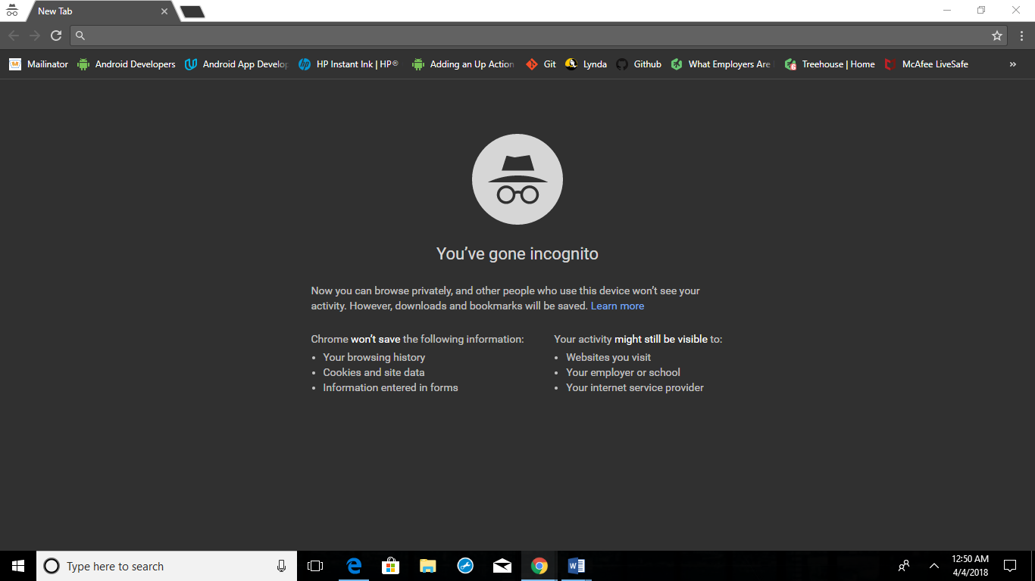
It allows me to browse without keeping track of my history

Q4. List 5 symptoms that your computer could be infected by a virus: Slower Internet and Processing
Unexpected Computer Behavior
Error Messages
Advertisements
Outgoing Emails

Q5. Using Google Chrome write steps on how do you delete your browsing history?
On your computer, open Chrome
At the top right, click More
Click History
On the left, click clear browsing data
From the drop – down menu, select how much history you want to delete
Check the boxes for the info you want chrome to clear, including browsing history.

Q6. List the definition of “Phishing” and give one example of how it is used:
Phishing is the fraudulent practice of sending emails purporting to be from reputable companies in order to induce individuals to reveal personal information, such as passwords and credit card numbers.
Examples: Generic Greeting. Phishing emails are usually sent in large batches. To save time internet criminals use generic names likes Georgia Bank Customer, so they don’t have to type all recipients’ names out and send emails one after another. If you don’t see your name, be suspicious.

Q7. Screenshot an example of Scareware and what is their purpose?
The purpose of scareware is to frighten people into purchasing fake software
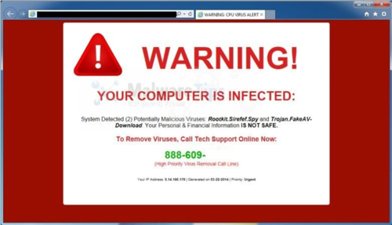

Q8. List the 2 primary ways that one can catch a computer virus:
When an infected file is executed.
When a computer is booted from an infected disk, the concealed virus is executed.

Q9: Show the task manager screenshot that you can use to determine if your system is infected:
